**Secrets to Growing and Caring for Succulents the Right Way**

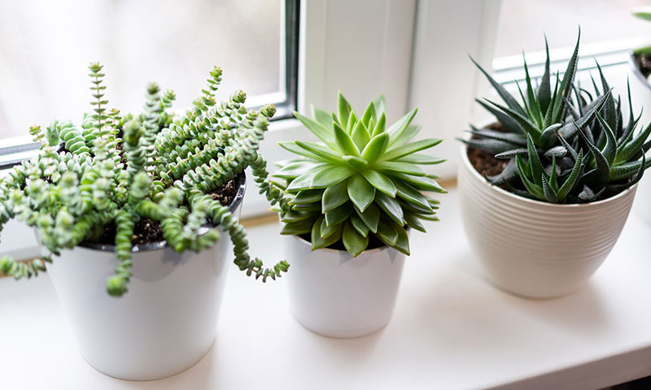

Succulents are a shining star in the world of ornamental plants, loved for their unique beauty and subtle elegance. However, to successfully grow and nurture succulents, specific tips and techniques are essential. **Green Grove**s is here to share the key secrets and methods to help your succulents thrive!

**1. Introduction to Succulents**

Succulents have long been symbols of serenity, thanks to their distinctive and refined appearance. They bring a sense of greenery and tranquility to any home. Known for their ability to adapt to harsh environments, succulents are an ideal choice for plant enthusiasts, even those new to gardening.

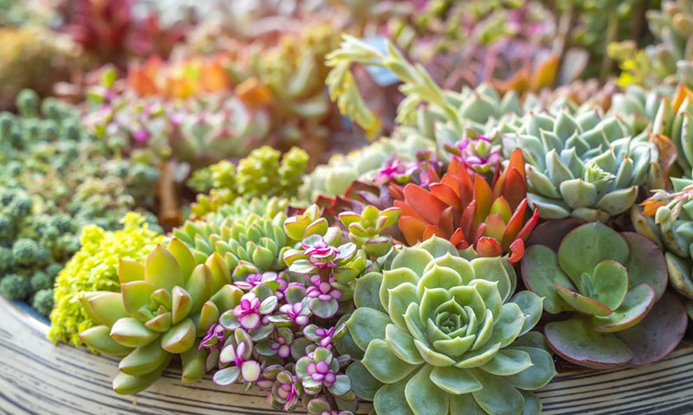

**2. How to Plant Succulents in Pots**

Planting succulents is a wonderful way to create a refreshing and relaxing natural space in your garden or home. Follow these steps for successful succulent planting:

**Steps to Plant Succulents:**

* Choose the Right Pot:
  + Select a pot with an appropriate diameter and depth to accommodate the growth of your succulent.
  + Ensure the pot has drainage holes to prevent waterlogging.
* Prepare the Growing Medium:
  + Mix soil with sand and a small amount of organic fertilizer to create a well-aerated, well-draining environment.
* Layer the Pot:
  + Place a layer of growing medium at the bottom of the pot to facilitate water drainage.
* Plant the Succulent:
  + Position the succulent at the center of the pot and surround its roots with the growing medium.
  + Evenly distribute the medium to fully cover the roots.
* Watering:
  + Water gently after planting to moisten the soil. Avoid overwatering to prevent waterlogging.
* Placement and Light:
  + Place the pot in a location with natural light, avoiding direct sunlight, which can scorch the leaves.
* Regular Care:
  + Monitor soil moisture and water as needed.
  + Inspect leaves and roots regularly for signs of issues. Remove dried leaves or shoots to encourage healthy growth.

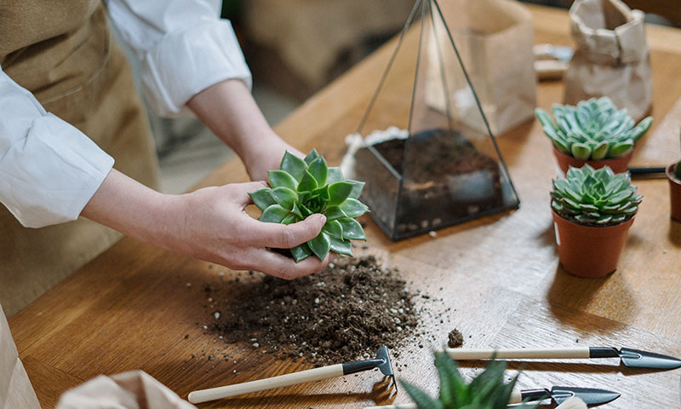

**3. Caring for Succulents**

Proper care is essential to keep your succulents healthy and thriving. Here are the key aspects:

* Watering:
  + Succulents need stable moisture but dislike standing water.
  + Water consistently, ensuring the soil stays moist but not soggy.
  + Allow the soil to dry slightly between waterings.

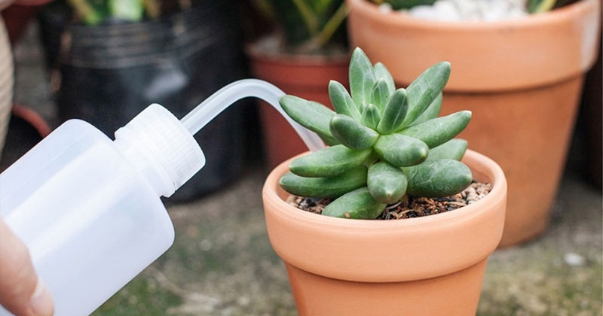

* Light and Temperature:
  + Succulents thrive in direct sunlight for several hours daily.
  + Place them in well-lit spots and avoid extreme heat or cold.
* Fertilizing:
  + Use organic fertilizer sparingly, about every 2–4 weeks during spring and summer.
  + Follow product instructions to avoid over-fertilization.
* Pruning and Cleaning:
  + Remove dry leaves or branches to make space for new growth and prevent disease.
  + Shape the plant to enhance aesthetics and promote flowering.

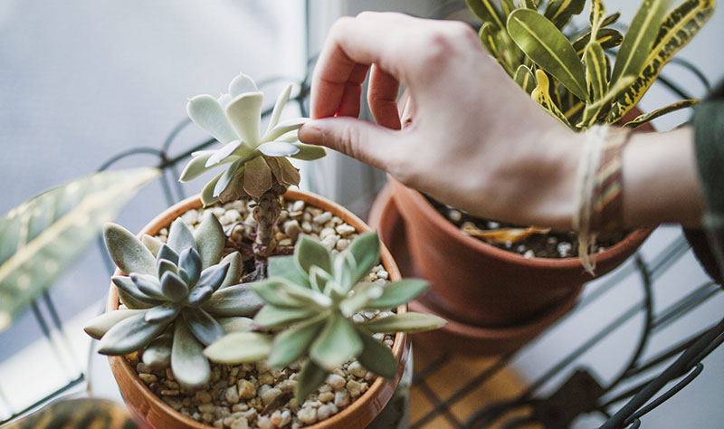

**4. Important Tips for Growing and Caring for Succulents**

* Choose Quality Plants:
  + Select fresh, healthy succulents with strong roots for better growth.

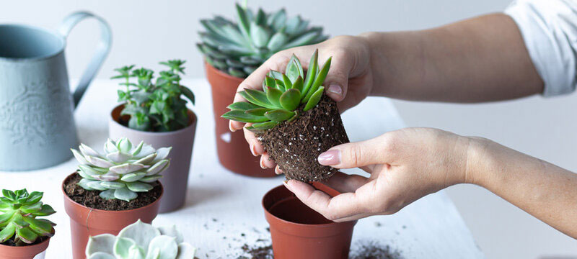

* Optimal Soil:
  + Use soil with excellent drainage and organic content, or create your own mix with:
  + Sandy soil or specialized succulent soil.
  + Organic fertilizer for growth and vibrant colors.
  + Gravel or pumice to improve drainage.
  + Vermiculite or coconut coir to retain moisture without waterlogging.

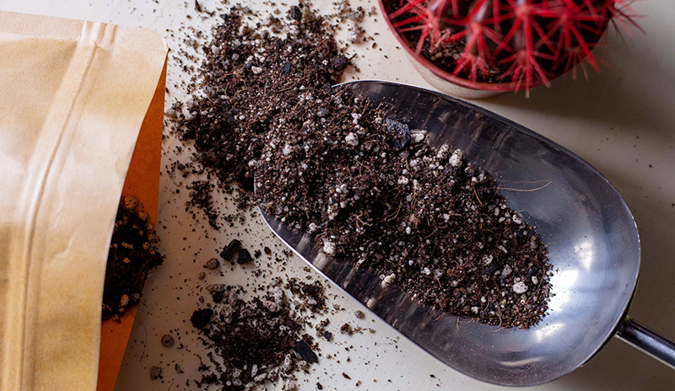

* Light and Temperature:
  + Succulents prefer ample sunlight and thrive in temperatures between 20–30°C (68–86°F).
* Watering Routine:
  + Water when the soil dries out, avoiding overwatering.
* Flowering Period:
  + Provide adequate light, water, and nutrients to encourage robust flowering.

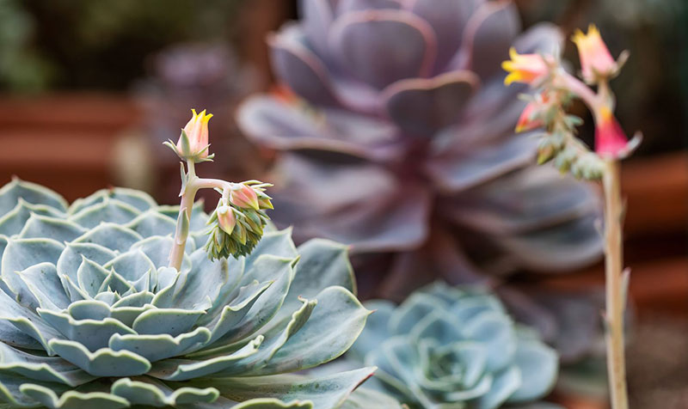

Planting and caring for succulents the right way ensures their healthy growth and vibrant beauty. By choosing the right pot, growing medium, and care routine, your succulents will not only thrive but also enhance your living space with their elegance. Regular observation, balanced watering, and occasional fertilization will help keep these low-maintenance plants in their best condition.

Start your succulent journey today, and let their charm transform your home! 🌵